Online Check-In via Gotsoccer

- Log in to your team account in Gotsoccer

- Select the Midwest Labor Day Tournament event registration

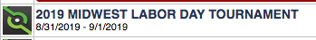

- Go to the Documents tab

- Upload the required documents

