How to create a scheduling request in Gotsoccer

- Log in to your team account in Gotsoccer

- Select the Midwest Labor Day Tournament event registration

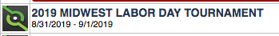

- Go to the Support and Feedback tab

- Choose “Open a Support Ticket” and then type in your request
